Creating Microservices for Account and Loan
Hands-on Exercise Report – Spring Boot Microservices

1. Objective
The goal of this exercise was to build two independent Spring Boot RESTful microservices for a bank — one to handle account details and another to handle loan details. Each microservice was created as its own standalone Maven project with its own pom.xml, with no shared code and no backend/database connectivity, since both endpoints simply return a fixed dummy response.

2. Project Setup
A folder named "microservices" was created to hold both projects. Two separate Spring Boot projects were generated using Spring Initializr (start.spring.io) with the following configuration:
- Group: com.cognizant
- Artifact (Project 1): account
- Artifact (Project 2): loan
- Dependencies selected: Spring Web, Spring Boot DevTools
Both projects were extracted into the microservices folder, then built individually from the command line using Maven to confirm they compiled correctly before writing any code:
mvn clean package
Both builds completed with a BUILD SUCCESS result.

3. Environment Setup
Since Maven and Java were not initially configured on the system, the following environment variables were set up before the projects could be built:
- JAVA_HOME → pointing to the installed JDK 17 folder
- MAVEN_HOME → pointing to the extracted Apache Maven 3.9.16 folder
- Path → updated to include %JAVA_HOME%\bin and %MAVEN_HOME%\bin
After correcting a couple of path mismatches and removing a duplicate Path entry, both "java -version" and "mvn -version" commands worked correctly, confirming Java 17.0.12 and Apache Maven 3.9.16 were ready to use.

4. Development Environment
Both projects were imported into IntelliJ IDEA (used in place of Eclipse, which is functionally equivalent for this exercise). Each project was opened as a separate window so both services could be run and monitored independently.

5. Account Microservice Implementation
A REST controller class, AccountController, was added to the account project to expose an endpoint that returns dummy account details based on the account number passed in the URL.
package com.cognizant.account;

import org.springframework.web.bind.annotation.GetMapping;
import org.springframework.web.bind.annotation.PathVariable;
import org.springframework.web.bind.annotation.RestController;

import java.util.HashMap;
import java.util.Map;

@RestController
public class AccountController {

@GetMapping("/accounts/{number}")
public Map<String, Object> getAccountDetails(@PathVariable String number) {
Map<String, Object> account = new HashMap<>();
account.put("number", number);
account.put("type", "savings");
account.put("balance", 234343);
return account;
}
}
The Account service was launched by running AccountApplication, which started an embedded Tomcat server on the default port 8080.

6. Loan Microservice Implementation
Similarly, a LoanController class was added to the loan project to expose an endpoint for retrieving dummy loan details.
package com.cognizant.loan;

import org.springframework.web.bind.annotation.GetMapping;
import org.springframework.web.bind.annotation.PathVariable;
import org.springframework.web.bind.annotation.RestController;

import java.util.HashMap;
import java.util.Map;

@RestController
public class LoanController {

@GetMapping("/loans/{number}")
public Map<String, Object> getLoanDetails(@PathVariable String number) {
Map<String, Object> loan = new HashMap<>();
loan.put("number", number);
loan.put("type", "car");
loan.put("loan", 400000);
loan.put("emi", 3258);
loan.put("tenure", 18);
return loan;
}
}

7. Port Conflict Observation
With the Account service already running on port 8080, the Loan service was launched without any port configuration to observe Spring Boot's default behaviour. As expected, the application failed to start because port 8080 was already occupied by the Account service:
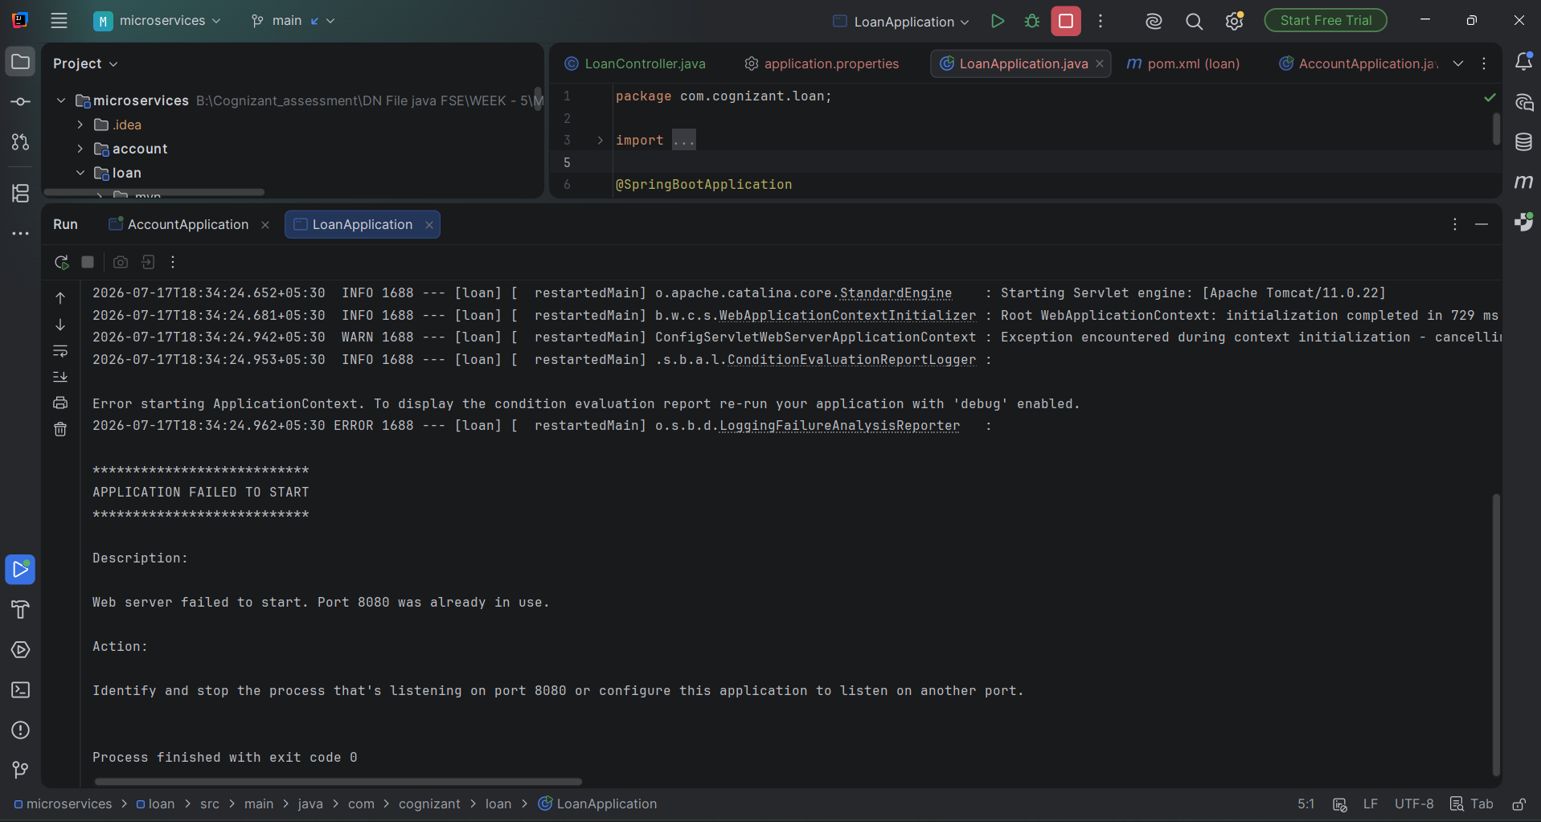
Figure 1: Loan service failing to start — "Web server failed to start. Port 8080 was already in use."
This confirmed that, by default, every Spring Boot application attempts to start on port 8080, and only one process can bind to that port at a time.

8. Resolving the Port Conflict
To resolve this, the following property was added to the loan project's application.properties file, assigning it a different port:
server.port=8081
After adding this property, the Loan service was restarted and started successfully on port 8081, running alongside the Account service on port 8080 without any conflict:
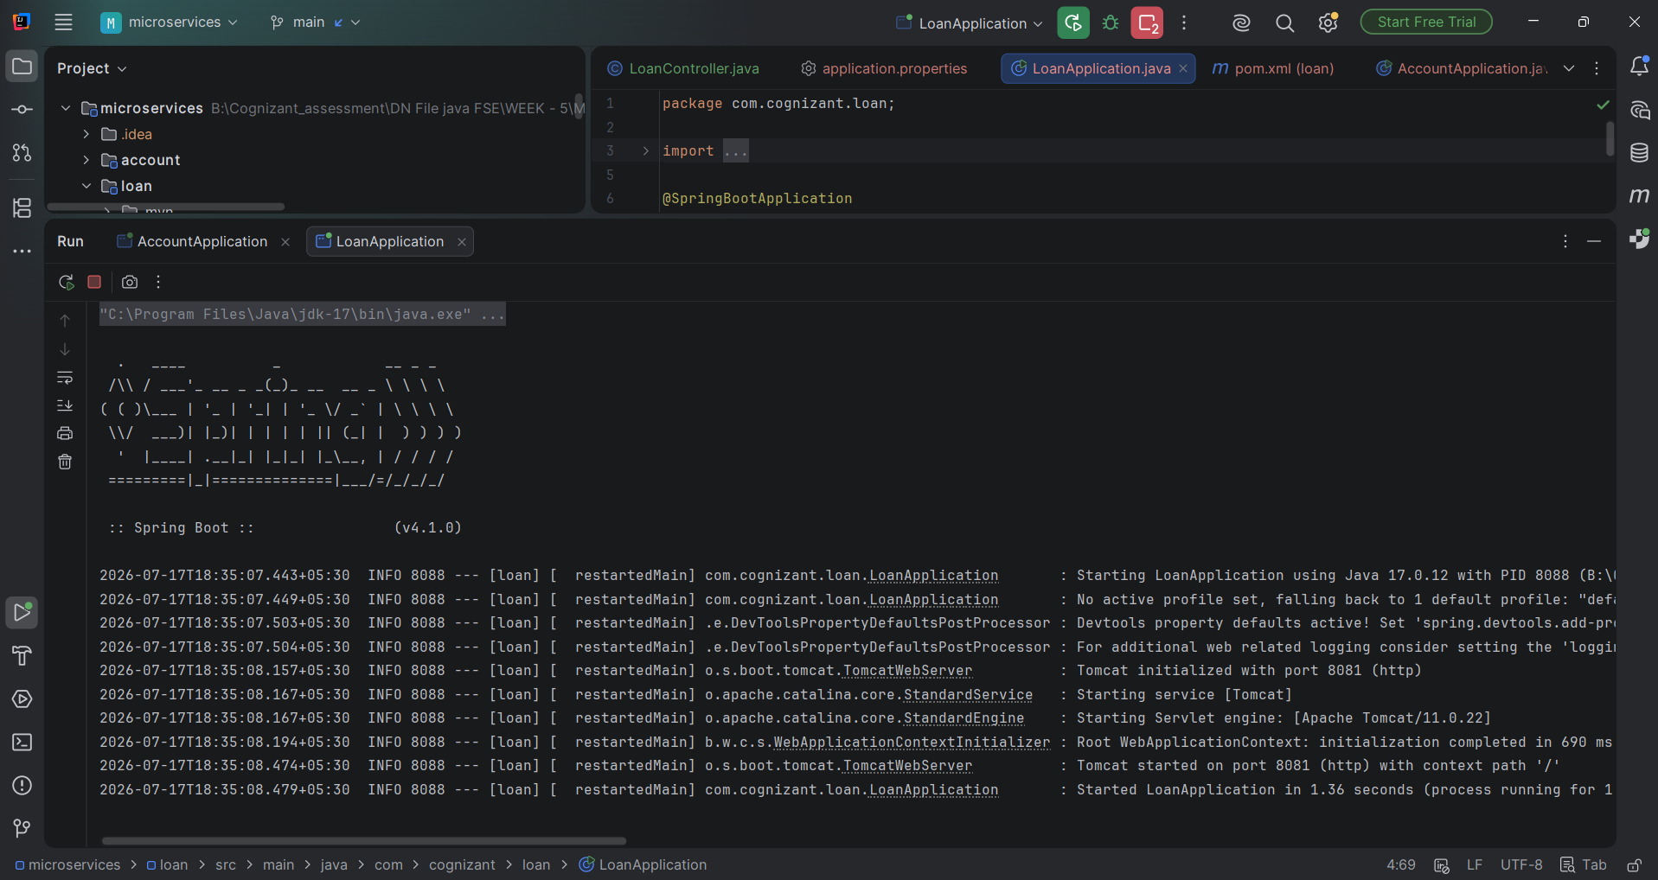
Figure 2: Loan service starting successfully on port 8081 after adding the server.port property

9. Testing Both Services
With both services running simultaneously, each endpoint was tested directly in the browser using a sample account number and a sample loan number.

Account Service — GET /accounts/{number}
Request: http://localhost:8080/accounts/00987987973432
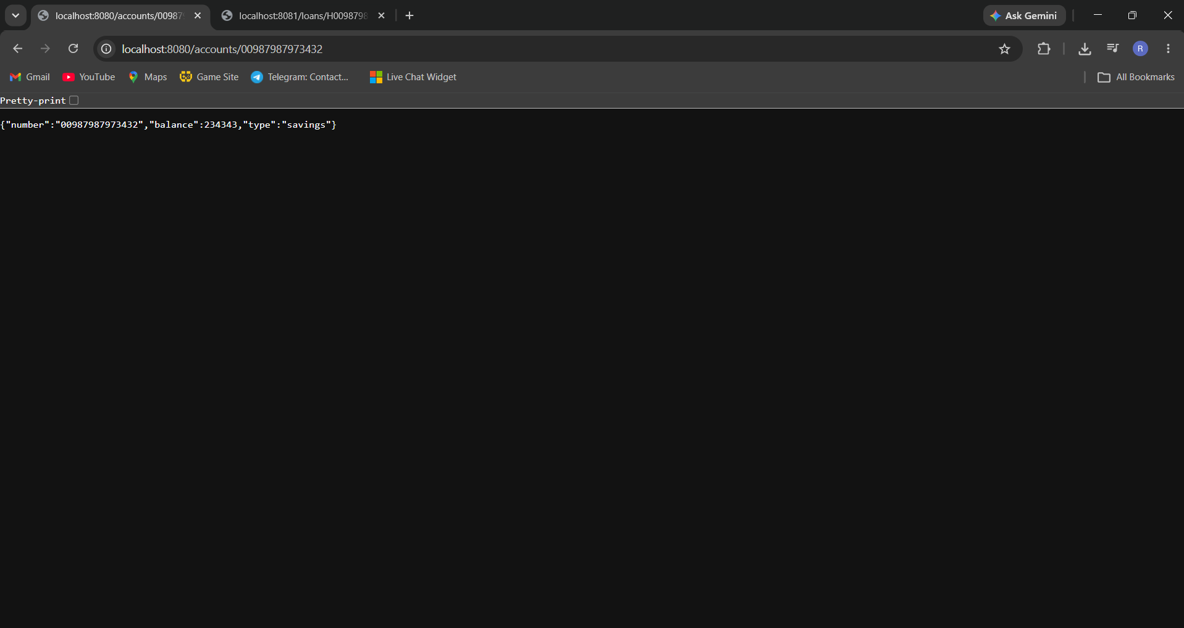
Figure 3: Account service response on port 8080

Loan Service — GET /loans/{number}
Request: http://localhost:8081/loans/H00987987972342
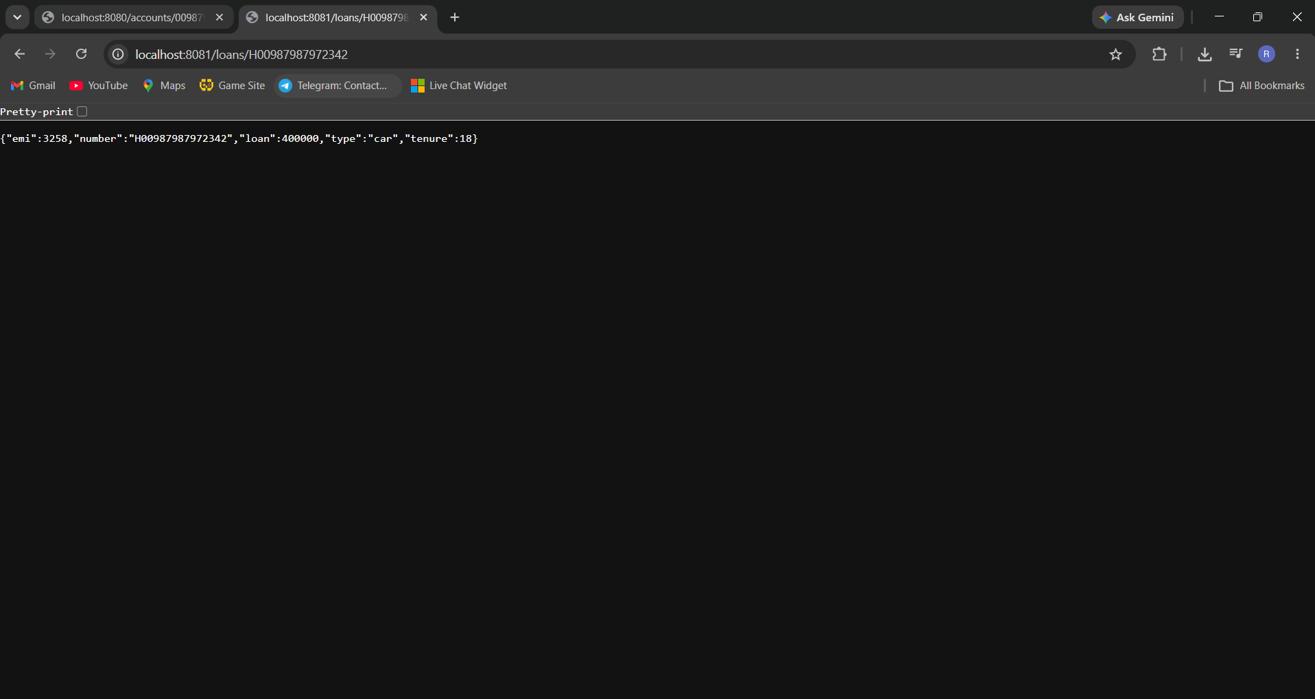
Figure 4: Loan service response on port 8081

10. Conclusion
Both microservices were successfully created as independent Maven projects, each with its own pom.xml, controller, and REST endpoint. The exercise demonstrated the default port conflict that occurs when multiple Spring Boot applications are run together, and how the server.port property is used to run each microservice on a distinct port. With the fix in place, the Account and Loan microservices were verified to run at the same time on ports 8080 and 8081 respectively, each correctly returning its expected dummy JSON response.

